NON-PROFIT ORGANIZATION

WEBSITE

WT MINI-PROJECT REPORT

*By*

Sanfer Noronha

Benita Rego

*Under the guidance of*

Prof. Monali Shetty

A**BSTRACT**

In this mini project, we have built a web application for a Non-Profit Organization which helps them connect with the people outside who wish to volunteer for events conducted by the organization and donate for the organization. The staff of this organization can use the wesbite to manage their events which they host. The volunteers can register for the organization after which they can register for any events hosted by the staff of the organization. The project is built using Vue.js, Vuetify and Firebase.

**Problem Statement and Objectives**

To build a website for a non-profit organization where the volunteers can register for their events as well as donate to the organization. The staff should be able to login and create his/her event, edit as well as see the list of volunteers who registered for the event. The registered volunteers should be able to login, view the events list created by all staff and register for the same. They should also be able to see the list of events they have registered for.

There are many in world , who are so learned who see life beyond money and life and life above happiness and life above happiness is when you see people smile because and is the true meaning of being born to humans. Only a couple of people understand it and they donate money help the ones who are in dier need .

Introduction

Non-governmental organizations - commonly referred to as NGOs, are usually non-profit independent of governments, many are active in humanitarian etc. areas. NGO activities include, but are not limited to, environmental, social, advocacy and human rights work. They can work to promote social or political change on a broad scale or very locally. NGOs play a critical part in developing society, improving communities, and promoting citizen participation. First of all ,when you want to know how a NGO works all you need to do is to know about its basic realm, rest with time and tide you will come to know better about it . A NGO or better said as Non Governmental Organisation is an independent firm that works for the welfare of the people and itself as the name is not a part of governmental body rather is a registered under acts and laws in eye of the government .It is a body that usually works for involvement of people into recreational activities ,in general some time even leading them to earn their bread and butter also. NGO's also play a vital role when a particular place struck natural calamity ,in short a NGO can be said to be a condolence body which pushes everyone from bad to good .Here ,many volunteers who sum up together to be helping hands to these sort of firms so that humanity counties to be bestowed upon the human race .Now after knowing this a basic question must popping out in every readers mind is “All is fine..but where does the funds come from” and the answer to this question is …Volunteers can volunteer for many different domains like funding, teaching, healthcare, activists, campaigning etc.

Problem Statement Analysis

This website can be used by everyone. People who visit the website should be able to read about the organization and get acquainted with the mission and our impact. The user should also be able to join the movement by registering as a volunteer. There is a donation section for people who would like to make a kind donation. We provide a efficient way to login and use the system as a staff and as a volunteer. The staff should be able to create events and manage events using the interactive dashboard. The volunteers, through their dashboard can register for events and view their ongoing and completed events. The user interface and the functionalities for all the above mentioned features can be developed fast and robustly using VueJS and the Vuetify library.

Design and Methodology of proposed system

This application describes the methodology and approach adopted for the research. Research. Methods may be understood as all those techniques that are used for conducting the research. In other words, all those methods which are used by the researcher during the course of studying his research problem are termed as research methods.

For̥ the first web page, we have made the home page where all the pages can be accessed like Home itself, What we do, Out impact, Join the Movement, Donate, faqs, privacy policy, contact us and button to all the ngo’s social media sites. From any page, the pages listed above can be accesed by clicking on that specified buttons. The home page even includes volunteer and staff login.

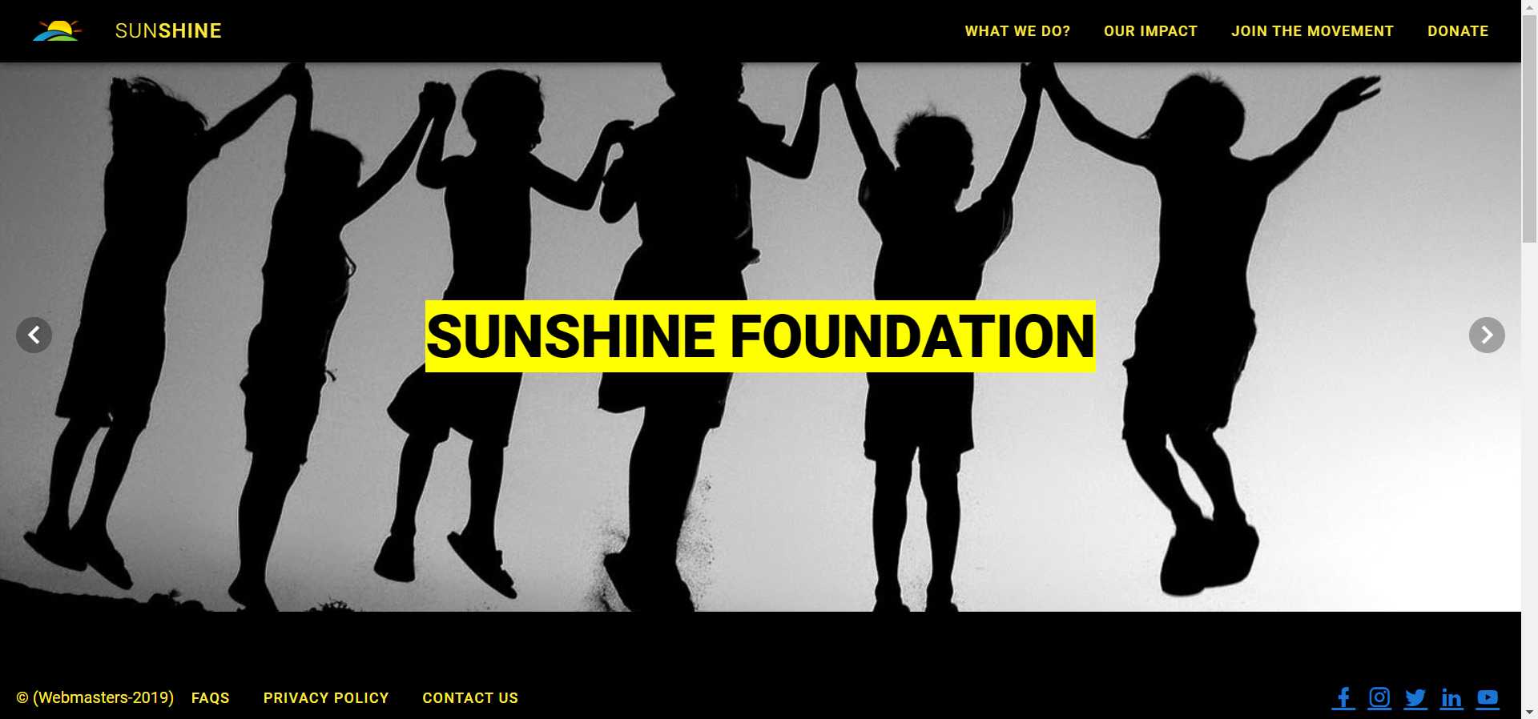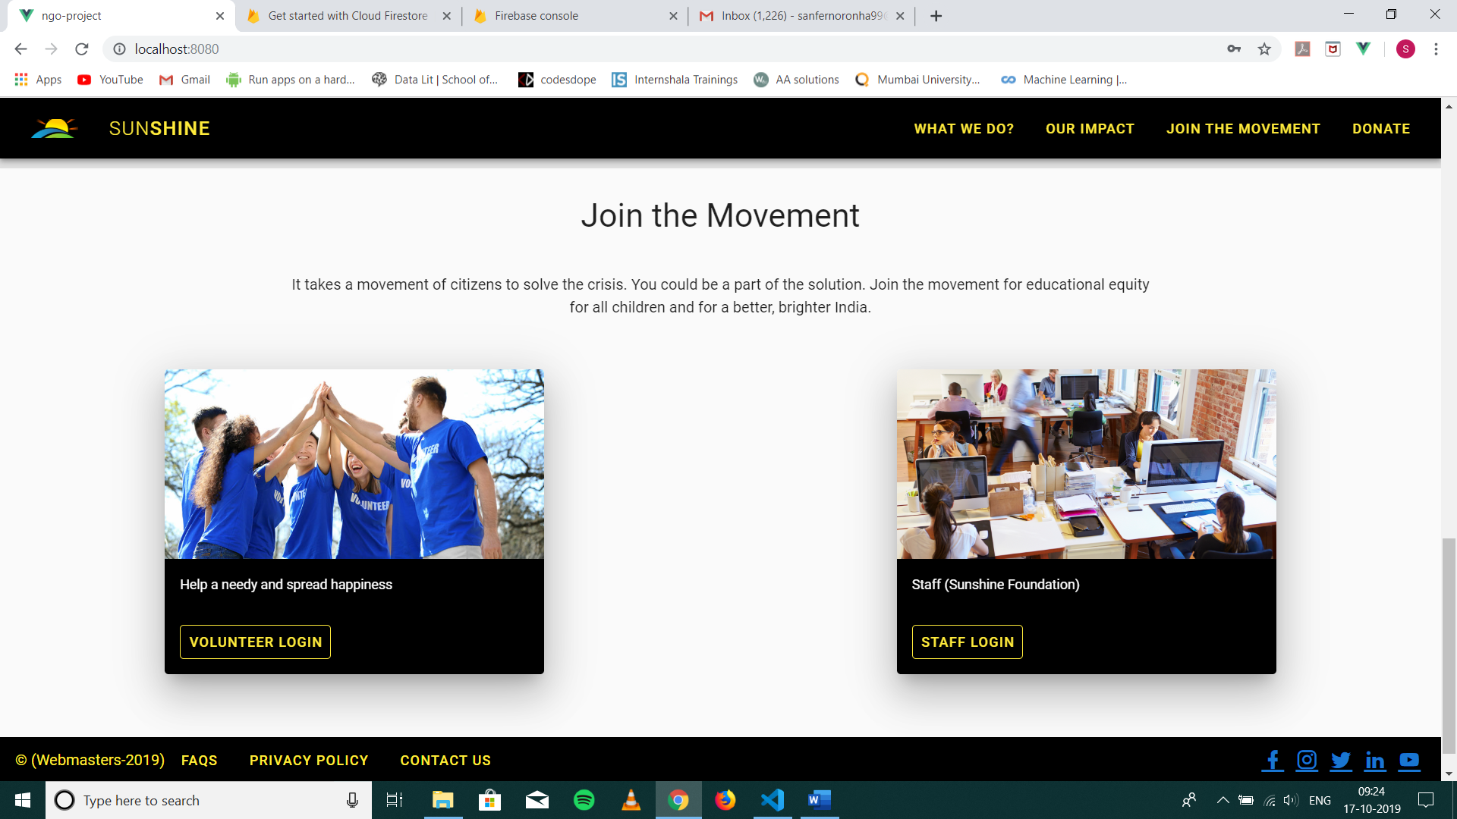

“What we do?” page and “Our impact” page has the information of the NGO on their mission, their impact and what they do.

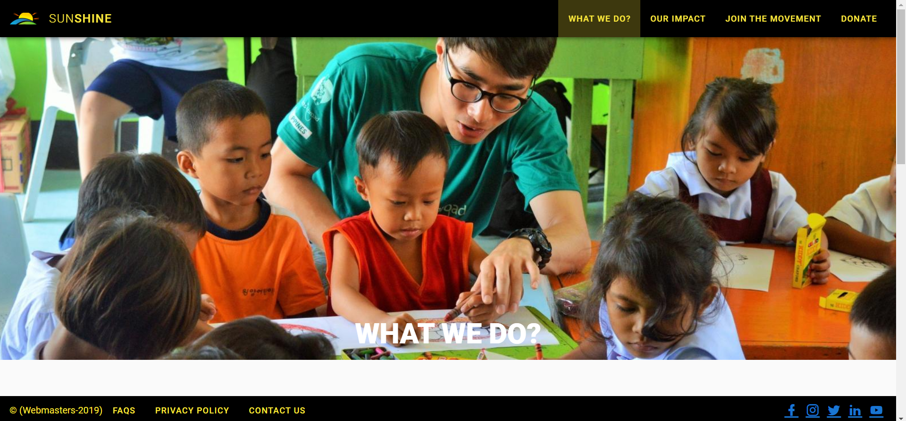

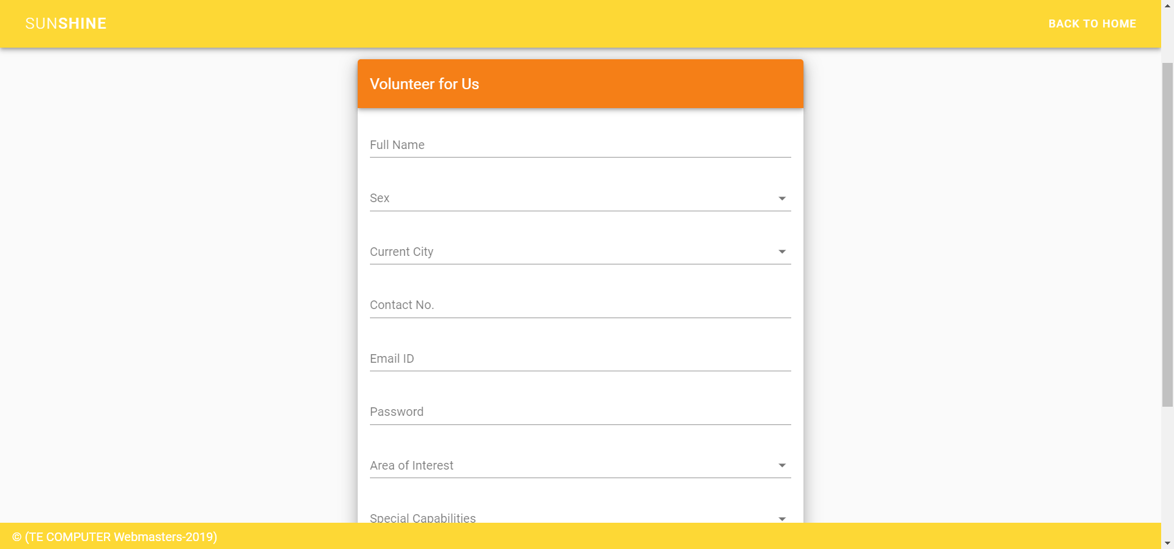In “Join the Movement” page, people can register as volunteers by clicking on the button below “Join Now”.

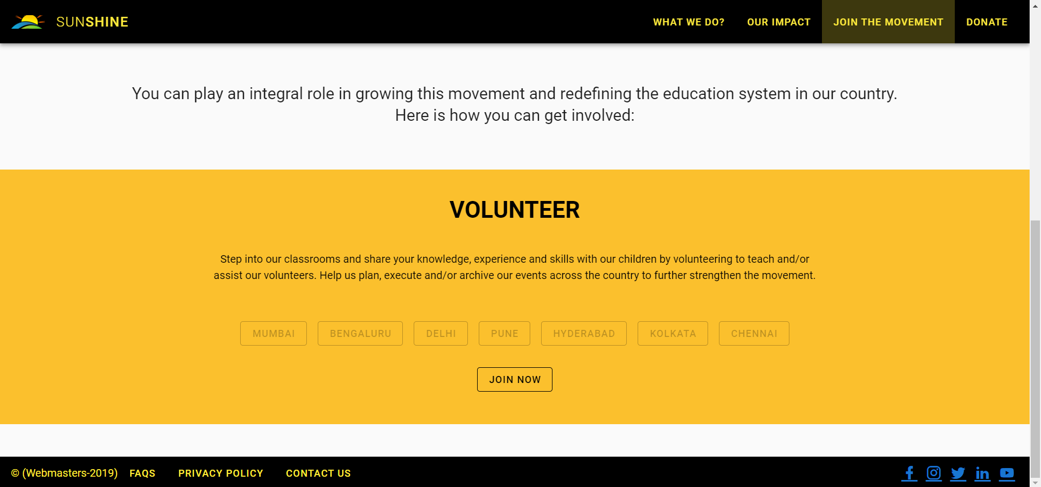

In FAQs page, all the faqs related to registering as volunteers and application process for staff is given.

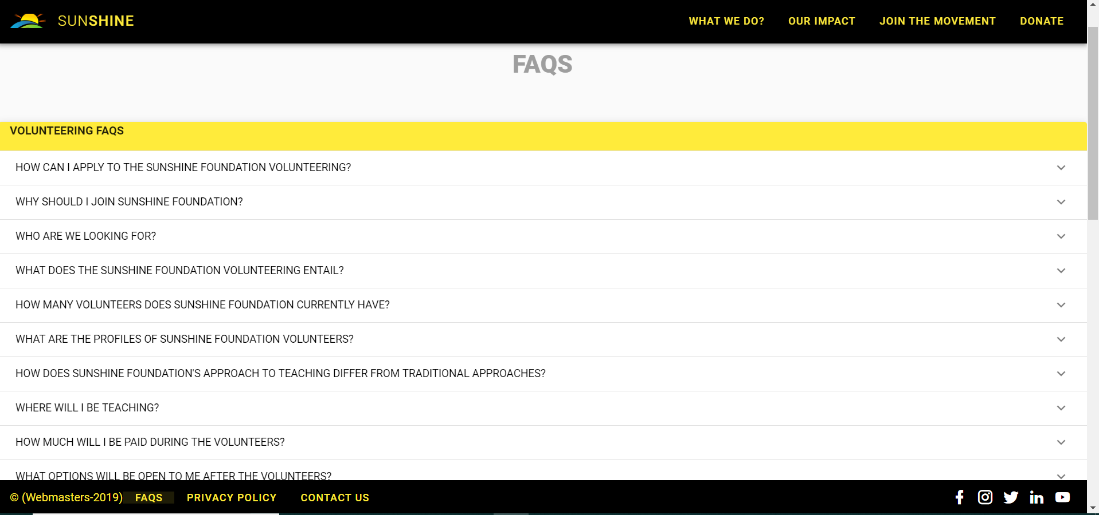

Privacy Policy page has privacy policy agreement of the organizaton.

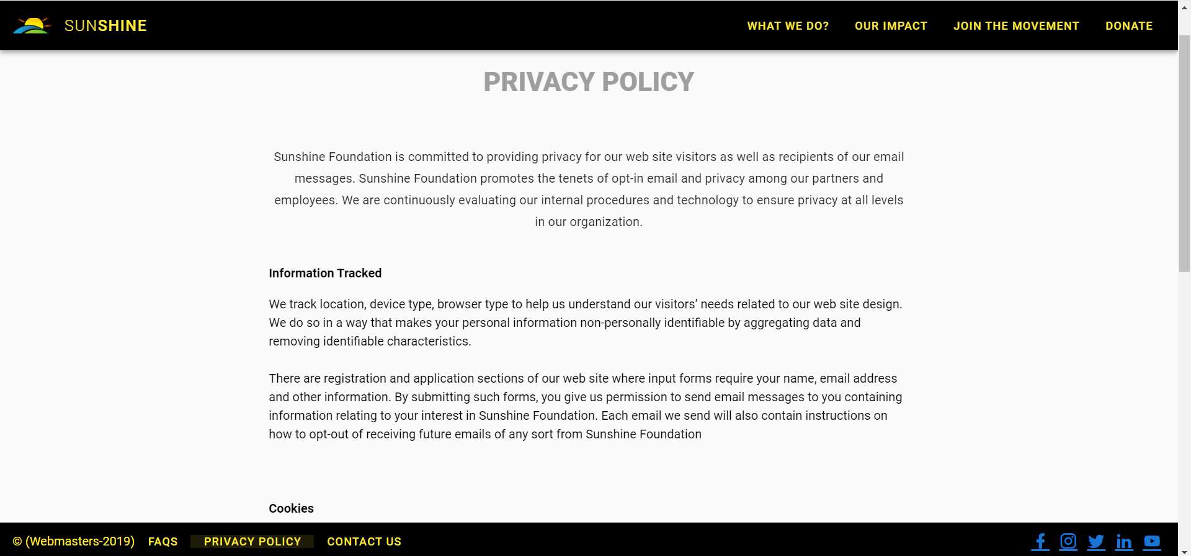

In the Contact Us page, contact details of all the offices across India is listed and can be contacted.

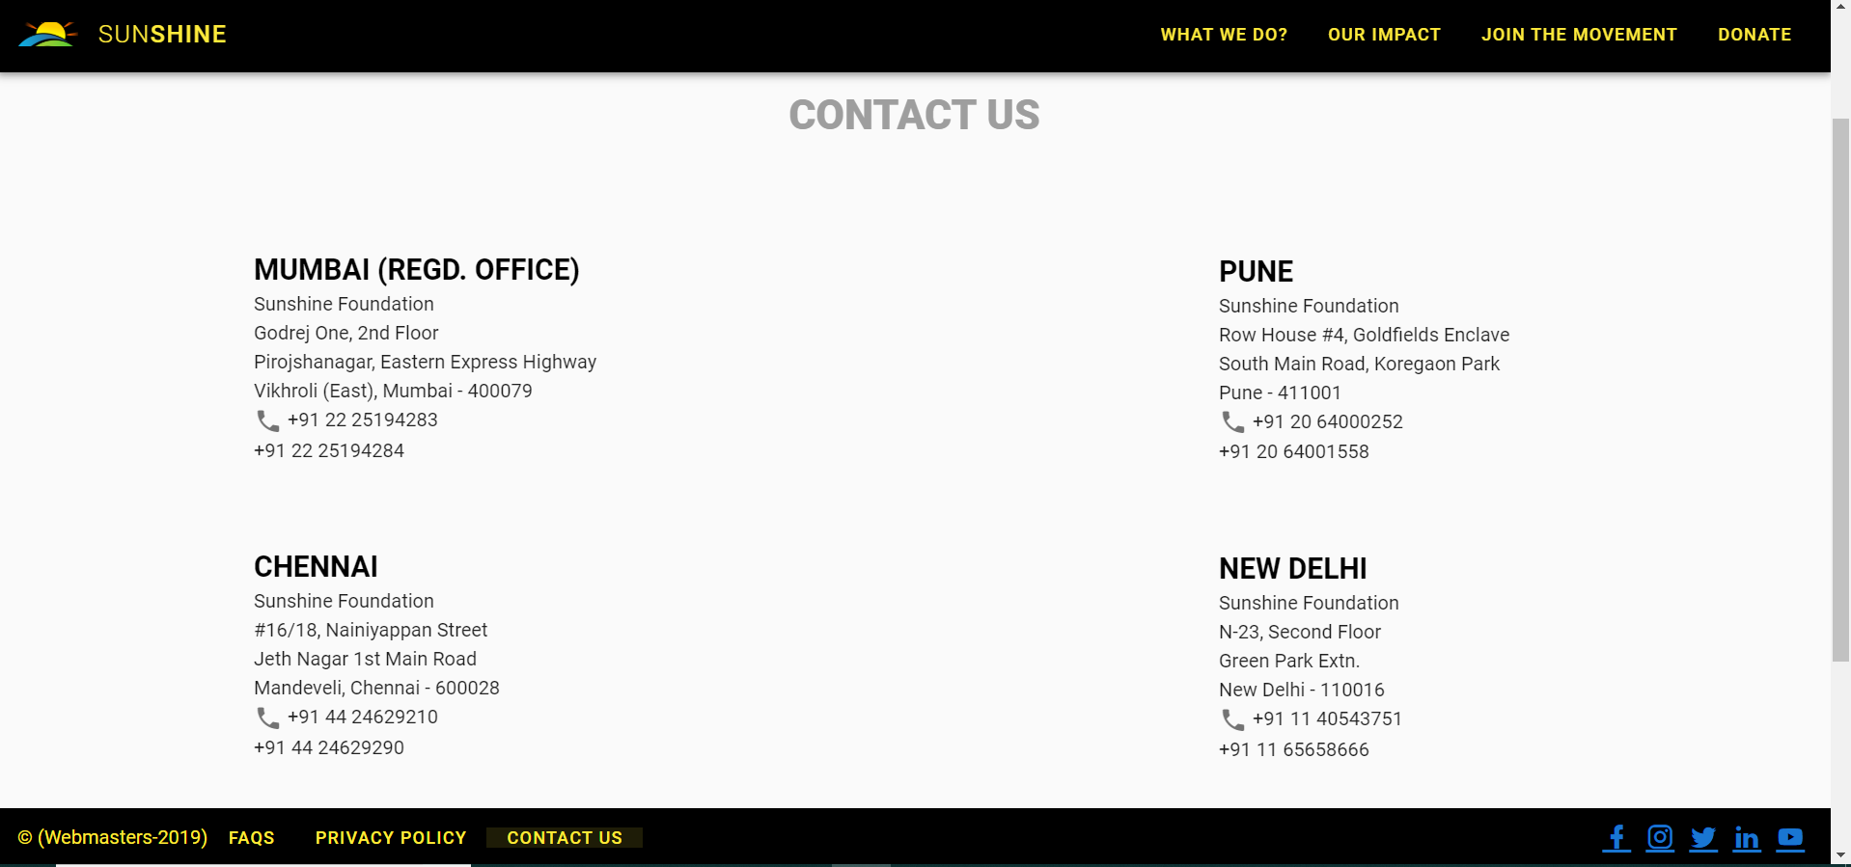

The Volunteer Login button on the home page goes to the login page where the registered volunteers can login using email and password. Staff or any other person cannot login here or else an error will be shown. So here, after logging in, an interactive dashboard comes up where the volunteer can view the profile, my completed will show the events finished , my on-going will show the ongoing events and all events created by all staffs and logout.

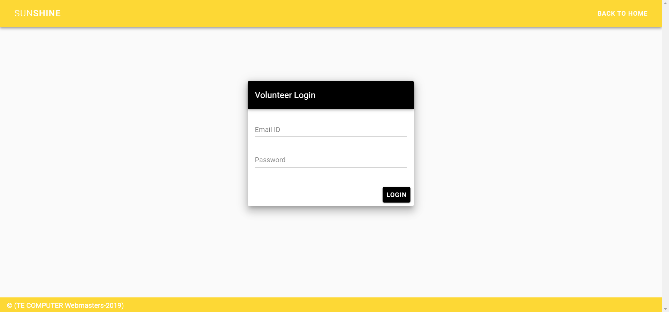

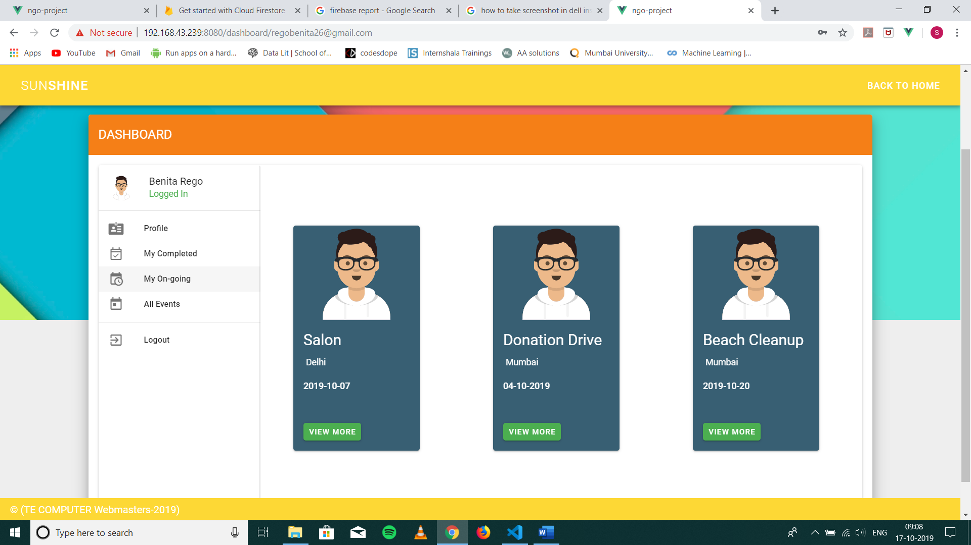

The Staff Login button on the home page goes to the login page where the staff can login using email and password. Volunteers or any other person cannot login here or else an error will be shown

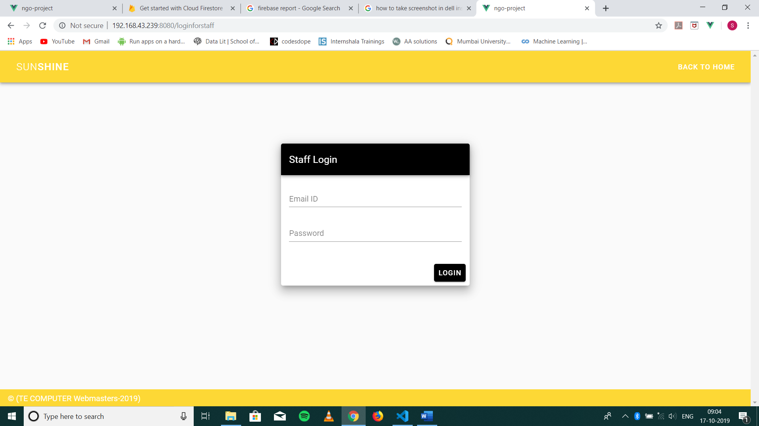

So here, after logging in, an interactive dashboard comes up where the staff can view the profile,my events will show his events created, my volunteers will show volunteers registed for that particular event and create event will allow the staff to create an event and logout.

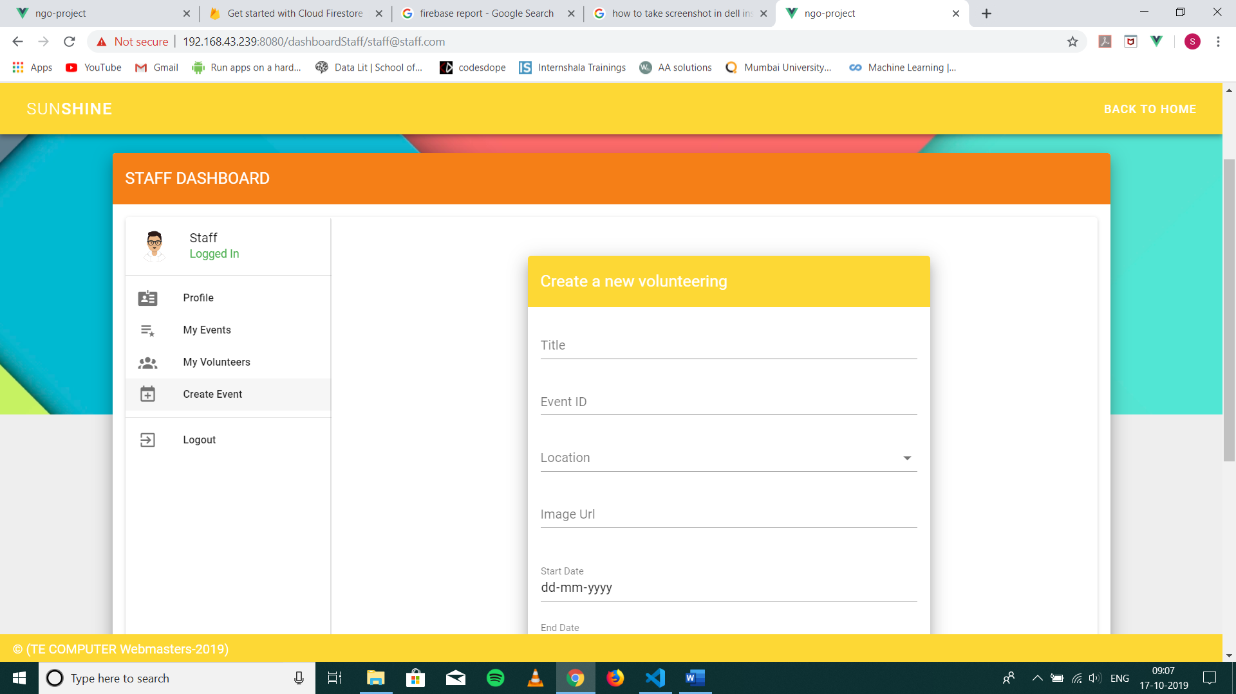

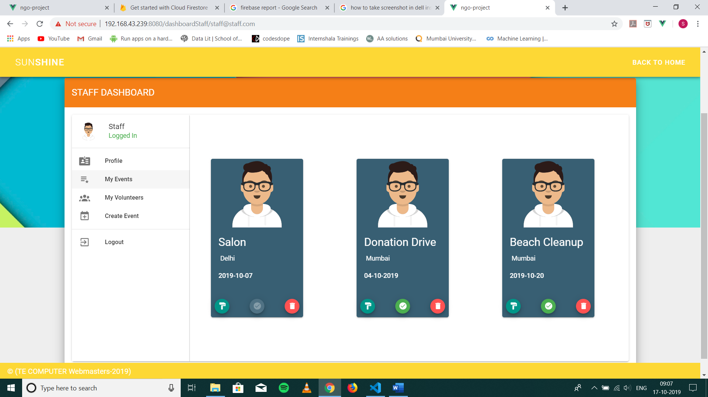





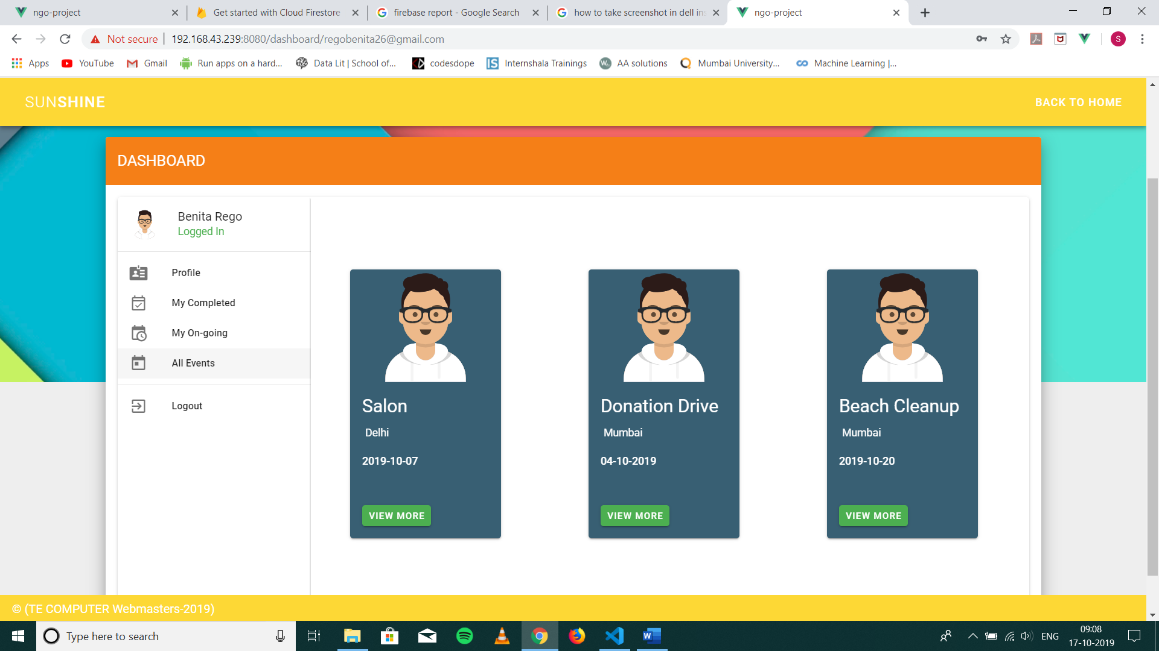The necessary authentications needed for the login part has been done by Firebase. The volunteers data, staff data, events data are all created in Firebase.

Hardware software requirements and Implementation

This project has used an offline compiler Visual Studio. The design and frontend is built using Vue.js and Vuetify along with RegEx. The backend is built using Firebase.

Result

We have successfully built a Web Application for a Non-Profit Organization where the user can find all relevant information about the NGO, register as volunteers, donate for the orgnanization, staff and volunteers can login and use the features built for this website.

Conclusion

This web application brings out the exact design proposed for the user as well as the organization to view all relevant information about the NGO, register, login, donate and contact them whenever needed. Thus, this website has all the user as well as the organization’s need.

References

* <https://github.com/benitarego/NGO-website>
* <https://www.smilefoundationindia.org/>
* <https://www.teachforindia.org/>
* <https://www.careindia.org/>